Objectives of this assignment:

* to explore time complexity and “real time” of a well-known algorithm
* USE THIS FILE AS THE STARTING DOCUMENT YOU WILL TURN IN. **DO NOT DELETE ANYTHING FROM THIS FILE:** JUST **INSERT** YOUR ANSWERS.
* IF USING HAND WRITING (STRONGLY DISCOURAGED), **USE THIS FILE** BY CREATING SUFFICIENT SPACE AND WRITE IN YOUR ANSWERS.
* FAILING TO FOLLOW TURN IN DIRECTIONS /GUIDELINES WILL COST **A 30% PENALTY.**

What you need to do: (Use this file to INSERT your answers as indicated below)

1. Implement the ***Merge-Sort*** algorithm to sort an array. (See Appendix for the *Merge-Sort* algorithm)
2. Collect the execution time T(n) as a function of n
3. Plot the functions T(n)/ $n$, T(n)/n.log2(n), and T(n)/ $n\sqrt{n}$ as a function of n on three separate graphs.
4. In Module 4, we establish that the running time T(n) of *Merge-Sort* is Θ(n.log(n)). Discuss T(n) in light of the graph you plotted above. Use the prediction techniques learned in M1: Programming Assignment (See Early questions trying to infer the shape)

**Objective**: The objective of this programming assignment is to design and implement in Java the Merge-Sort algorithm presented in the lecture to sort a list of numbers. We are interested in exploring the relationship between the time complexity and the “real time”. For this exploration, you will collect the execution time T(n) as a function of n and plot the functions T(n)/ $n$, T(n)/n.log2(n), and T(n)/ $n\sqrt{n}$ on the same graph (*If you cannot see clearly the shape of the plots, feel free to separate plots.*). Try to predict ahead the shapes of T(n)/ $n$, T(n)/n.log2(n), and T(n)/ $n\sqrt{n}$ to check whether your plots are correct. Finally, discuss your results.

**Program to implement**

collectData()

Generate an array G of **HUGE** length L (as huge as your language allows) with **random** values capped at some max value (as supported by your chosen language).

for n = 1,000 to L (with step 1,000)

copy in Array A **n** first values from Array G // **(declare Array A only ONCE out of the loop)**

Take current time ***Start*** // We time the sorting of Array A of length n

Merge-Sort(A,0,n-1)

Take current time ***End*** // ***T(n) = End - Start***

Store the value n and the values T(n)/ $n$, T(n)/n.log2(n), and T(n)/ $n\sqrt{n}$ in a file **F** where T(n) is the execution time

**Advice:**

**1)** The pseudocode assumes arrays that start with index 1. So, an array A with n elements is an array A[1], A[2]..., A[n-1], A[n]. With most programming languages, an array A with n elements is an array A[0], A[2]..., A[n-1], A[n-1]. When implementing pseudocode that uses some array A with $n$ elements, I advise you to declare an array with $n+1$ elements and just ignore (not use) A[0]. This way, you can directly implement the algorithm without worrying about indices changes.

**2)** When plotting, **ignore the first values of n= 1000, 2000, 3000, and 4000**. When a program starts, there will be some overhead execution time not related to the algorithms. That overhead may skew T(n).

**Data Analysis**

Use any plotting software (e.g., Excel) to plot the values T(n)/ $n$, T(n)/n.log2(n), and T(n)/ $n\sqrt{n}$ in File F as a function of n. File F is the file produced by the program you implemented. Discuss your results based on the plots. (**Hint**: is T(n) closer to $K.n$, $K. n.log2(n$), or $K. n\sqrt{n}$ where K is a constant? See M1: Programming Assignment).

Answer where indicated below. Recall that answers must be well written, documented, justified, and presented to get full credit.

This is how you run the program on a tux machine:

Navigate to the directory (I was on bmm0066@tux239) The file is just in that home directory.

programming_3.java should be there

type in “javac programming_3.java”

After compilation finishes, type in “java programming_3”

The program should run and it will output to the system how many iterations are done. It runs till 2000000. It takes a few minutes since I set it to give such a large amount of data. It took ten minutes to execute on my machine.

Once done, there should be a file called “Output.csv” with all the output data.

1. (25 points) Implement the ***Merge-Sort*** algorithm to sort an array. (See Appendix for the *Merge-Sort* algorithm)

a) State **here** whether your algorithm works. My algorithm works and produces data.

b) Insert here a screenshot showing that your implementation sorts correctly an array that contains 10 numbers.

For this I made my program print out the sorted array (of random ints from 0 to 10) to the console, I took this out for the turned in version of the code, since it takes so long to print out the 2 million item array from the data collection.

1. (10 points) Collect the execution time T(n) as a function of n. Record the values n, T(n), T(n)/ $n$, T(n)/n.log2(n), and T(n)/ $n\sqrt{n}$ in csv (comma-separated-values) file.

Turn in this csv file with your submission

Submitted on Canvas.

1. (3x15 points) Plot the functions T(n)/ $n$, T(n)/n.log2(n), and T(n)/ $n\sqrt{n}$ as a function of n on three separate graphs (15 points per graph)*.*

Insert here the three graphs/plots

Plot of T(n)/

Plot of T(n)/n.log2(n)

Plot of T(n)/ $n\sqrt{n}$

1. (20 points) In Module 4, we establish that the running time T(n) of *Merge-Sort* is Θ(n.log(n)).

Discuss here T(n) in light of the graphs you plotted above. Use the prediction techniques learned in M1: Programming Assignment (See Early questions trying to infer the shape of T(n) and determine the asymptotic growth). Discuss whether your plots confirm what we learned in Module M4.

Answer/elaborate/Justify.

Given that T(n) is Θ(n.log(n)), we can treat it like it is nlog(n) when calculating the asymptotic run time for our three functions: T(n)/ $n$, T(n)/n.log2(n), and T(n)/ $n\sqrt{n}$. Function 1 would simplify down to just be log(n), function 2 would become log(n)/log2(n), which would be equivalent to some constant k when it comes to time complexity, and function 3 would become log(n)/ $\sqrt{n}$. Pictures attached below of a graph of each of these functions.

From our plot of function 1 from last question, it doesn’t seem to match the graph of log(n) attached below. But this is because we are operating on a much larger scale than the graph below. The graph below only shows up to 90, while our plot is going to 2 million. Once you get to that scale for a log function, it begins to appear to be almost a constant horizontal line. So, ignoring the initial overhead execution time at the beginning of the plot, the graph returns exactly what we expected it to, a near constant horizontal line, that increases extremely slightly. Since our plot matches with what we expected for T(n)/n, that means our plot supports that the running time T(n) of *Merge-Sort* is Θ(n.log(n)).

According to earlier in this problem, our plot for function 2 should be some horizontal line. If we ignore the initial overhead execution time, the graph does exactly that and stays constant near some value less than 20. Since our plot showed the exact results we expected for T(n)/n.log2(n), that supports that the running time T(n) of *Merge-Sort* is Θ(n.log(n)).

According to earlier in this problem, our plot for function 3 should demonstrate the function log(n)/ $\sqrt{n}$. As seen by the last of the screenshots below, a plot of this function should approach 0 as n grows. Looking at our plot for function 3 from the last question, we see that it does exactly that. (Again, ignoring the initial overhead execution time.) Since our plot for this function approaches 0 as n grows, which matches the graph we looked up for T(n)/ $n\sqrt{n}$ = log(n)/ $\sqrt{n}$, our data supports that the running time T(n) of *Merge-Sort* is Θ(n.log(n)).

Since each plot matches the functions when we assume T(n) = nlog(n), this confirms that the tight bound is a good, and the best, representation of the asymptotic growth of the running time of the merge sort algorithm.

Graph of log(x)

Graph of log(n)/log2(n)

Graph of log(n)/ $\sqrt{n}$

**What you need to turn in:**

* Electronic copy of your source program of *collectData* program
* Electronic copy of the csv file recording the values n, T(n), T(n)/ $n$, T(n)/n.log2(n), and T(n)/ $n\sqrt{n}$.
* Electronic copy of this file (including your answers) (standalone). Submit the file as a Microsoft Word or PDF file.

**Grading**

* See points distribution assigned to each task/question

Appendix: Merge-Sort Algorithm.

At this stage, you do NOT need to understand Merge-Sort (It will be presented and explained in Module 4)). Implement Merge-Sort exactly the way it is described below. Replace the infinity value (∞) with 0x0fff ffff.

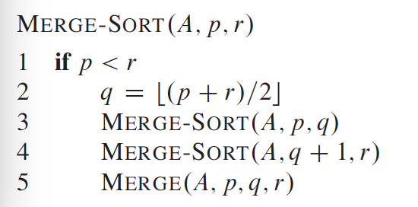

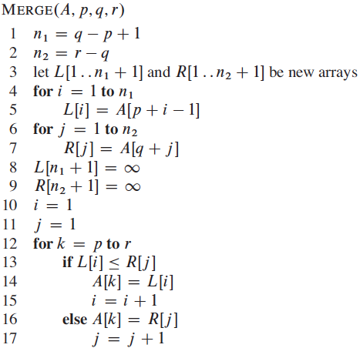f